**GENERAL INTEGRATED SCIENCE– UNIT 1**

**TASK 4 – Species Continuity & Change Test**

**NAME: _____________________________________ WEIGHTING: 5 %**

**DATE: _______________________________________ MARK: ______ / 35 =**

1. **There is a sudden drop in the outside temperature from 25 degrees to 10 degrees. How does the human body detect these changes?**
2. By checking your phones weather app.
3. Receptors in your nervous system detect the temperature change and inform your brain.
4. Your hairs have temperature receptors on their ends. This is why bald people cannot detect the cold.
5. Receptors in your respiratory system detect the change in air temperature and inform the spinal cord.

**2. All of the information for the traits and adaptations a species has is carried by..**

1. The male of a species
2. The DNA
3. Physiological adaptations
4. The nervous system

**3. When the external environment changes permanently, a species needs to change its traits permanently in order to survive. What is this process called?**

1. Adaptation
2. Reflex
3. Reaction
4. Variation

**4. Which of the following is NOT a type of adaptation?**

1. Behavioural
2. Physiological
3. Psychological
4. Structural

**5. Which of the following statements about behavioural adaptations is FALSE?**

1. Behavioural adaptations are the activities or behaviours that help an organism survive
2. Presence of thorns on plants and hair on animals are types of behavioural adaptations
3. Adaptations include digging burrows underground, living in trees, and dwelling in groups
4. These adaptations can be learned or instinctual

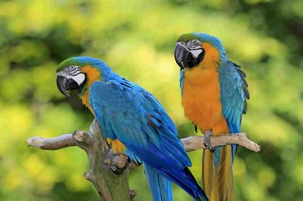

**6. Observe this picture of two birds.**

**This beak is most likely adapted to...**

1. Crack nuts
2. Drink nectar from flowers
3. Dig for insects
4. Tear at small animals like mice

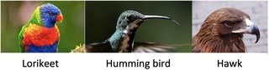**7. A fast-burning bush fire burnt through an Australian forest. It destroyed all of the small flowering-plants, leaving behind only the large gum trees with their gum-nuts. The attached image represents three species of birds that lived in this forest. One year after this bush-fire, which species would remain?**

1. All three
2. Only the Hawk
3. The Lorikeet and Hawk
4. Only the Hummingbird

**8. Mutations are a source of variation. How do they bring about variation within a species?**

1. They make the organisms prefer a certain appearance in a mate.
2. They cause permanent changes to the organism’s DNA.
3. They temporarily change the organism’s DNA.
4. None of the above.

**9. The tail of a male peacock, the size of a stag's (male deer) antlers and the larger size of male humans are all examples of...**

1. Mutations.
2. Sexual selection.
3. Behavioural adaptations.
4. Structural adaptations.

**10. How many black peppered moths were there in 1850?**

1. 5
2. 10
3. 25
4. 60

**11. Within one species, organisms have variation in their traits. Some of these traits make it more likely for the organism to survive and pass their genes on to the next generation, allowing the whole species to adapt. This is called:**

1. Sexual Selection
2. Structural Adaptations
3. DNA
4. Natural Selection

**12. Which of the following is not an example of asexual reproduction?**

1. Budding
2. Fragmentation
3. Segmenting
4. Binary Fission

**13. Which of the following types of organisms reproduces using binary fission?**

1. Animals
2. Bacteria
3. Yeast
4. Plants

**14. Which of the following is an advantage of asexual reproduction?**

1. It is quick
2. It makes highly varied offspring
3. It makes high-quality offspring
4. It can occur under any conditions

**15. How many chromosomes does a human normally have?**

1. 12
2. 18
3. 25
4. 46

**16. Mutations are always a bad thing.**

1. True
2. False

**17. Asexual reproduction takes longer than sexual reproduction.**

1. True
2. False

**18. The offspring in asexual reproduction are genetically identical to their parents.**

1. True
2. False

19. State one example of a physiological adaptation. *[1 mark]*

______________________________________________________________________________

20. Describe why species need to reproduce. *[1 mark]*

______________________________________________________________________________ ______________________________________________________________________________

21. Describe why it is important for a species to have variation between organisms.

*[1 mark]*

______________________________________________________________________________ ______________________________________________________________________________

______________________________________________________________________________

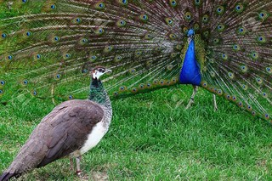22. Explain why the males of a species may look physically different to the females of a species. *[2 marks]*

______________________________________________________________________________ ______________________________________________________________________________

______________________________________________________________________________ ______________________________________________________________________________

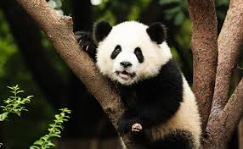

23. Panda's are a ground-dwelling species with a low reproductive-rate that require a lot of calories from plants to sustain them. They are now an endangered species. Suggest two reasons why Panda's are endangered and explain why these reasons make them endangered. *[3 marks]*

_____________________________________________________________________________________________________________________________________

______________________________________________________________________________ ______________________________________________________________________________

______________________________________________________________________________ ______________________________________________________________________________

______________________________________________________________________________ ______________________________________________________________________________

24. Based on your answer to Question 23, state two adaptations to improve the survivability of Panda's. *[2 marks]*

______________________________________________________________________________ ______________________________________________________________________________

______________________________________________________________________________ ______________________________________________________________________________

25. The process of adaptation takes many generations. If humans are changing the natural environment instead of nature, predict the impact that this will have on species survival.

*[2 marks]*

______________________________________________________________________________ ______________________________________________________________________________

______________________________________________________________________________ ______________________________________________________________________________

______________________________________________________________________________ ______________________________________________________________________________

26. State two disadvantages of sexual reproduction. *[2 marks]*

______________________________________________________________________________ ______________________________________________________________________________

______________________________________________________________________________ ____________________________________________________________________________________________________________________________________________________________

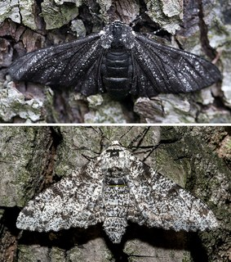27. Before the industrial revolution in Britain, most peppered moths were a pale white colour. This meant that they were camouflaged against the pale birch trees that they rest on. Moths with a mutant black colouring were easily spotted and eaten by birds. This gave the white variety an advantage, and they were more likely to survive to reproduce.

When the Industrial Revolution began, pollution in industrial areas blackened the birch tree bark with soot. This meant that the mutant black moths were now camouflaged, while the white variety became more vulnerable to predators. This gave the black variety an advantage, and they were more likely to survive and reproduce.

Explain what would happen to the number of black peppered moths compared to the white moths over time. *[3 marks]*

______________________________________________________________________________ ______________________________________________________________________________

______________________________________________________________________________ ______________________________________________________________________________

______________________________________________________________________________ ______________________________________________________________________________

______________________________________________________________________________ ______________________________________________________________________________

______________________________________________________________________________ ______________________________________________________________________________

______________________________________________________________________________ ______________________________________________________________________________